Mental Health in Tech Survey
- Introduction
The technology industry, which is praised for its unrelenting innovation and economic vibrancy, also has a high-pressure workplace culture that has led to a serious mental health crisis. Rising stress levels, burnout, and severe mental exhaustion are all caused by the industry's defining traits, which include long hours, rigorous project deadlines, fast-paced settings, and the growing isolation of remote work. In addition to being morally required of employers, addressing these issues is strategically necessary to retain talent and promote sustainable productivity.
In order to create a thorough, interactive dashboard that highlights important trends and insights, this project uses Tableau to analyze the "Mental Health in Tech Survey" dataset. Examining the intricate connections among demographics, workplace variables, treatment accessibility, and organizational support is the aim. This report offers a critical analysis of the results and a thorough design justification for the selected visualisations, supporting the dashboard made for the B9DA106 module.
1.1. Data Collection & Standardization
The "Mental Health in Tech Survey" dataset from Kaggle, which is openly accessible, serves as the basis for the analysis. The Open Sourcing Mental Illness (OSMI) organization conducted a survey in 2014 that gathered 1,259 responses in 27 columns about attitudes regarding mental health in the tech industry.
Source: https://www.kaggle.com/datasets/osmi/mental-health-in-tech-survey
The raw data needed to go through a number of standardization procedures in Tableau in order to guarantee the accuracy and clarity of the analysis:
Filtering by Age: Extreme outliers and negative values were among the inaccurate data in the Age column. To limit the age to a manageable range of 18 to 75, a data source filter was used. This keeps outliers from distorting aggregates and concentrates the analysis on a professional population.
Grouping by Gender: Due to its numerous variations, the free-text Gender field was difficult to use. A calculated field ("Cleaned_Gender") was developed to combine these entries into three standardized categories: Male, Female, and Other in order to facilitate meaningful analysis. Although it is acknowledged that this abstracts some of the original nuance, this grouping acknowledges the existence of non-binary identities and makes comparisons easier.
- Design Justification:
2.1. Dashboard Overview:
The dashboard contains 4 different visualisations exploring diverse analytical perspectives of mental health treatment in the tech industry.
- A stacked bar chart that shows treated employees by gender.
- A Symbol Map with circle markers showing Mental health treatment rate by Country.
- A horizontal bar chart of Mental Health treatment by work interference.
- Grouped bar chart that shows Work interference vs Support programs.
  - Choice of Visualisation Types:
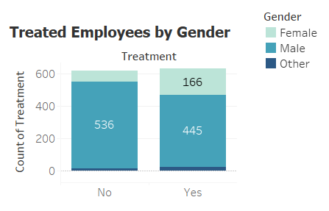
- Stacked Bar Chart: Treated Employees by Gender
Purpose: The main objective of this graph is to illustrate and contrast the gender distribution of two different groups: workers who have applied for treatment for a mental health issue and those who have not.
Design Justification: The purposeful selection of a stacked bar chart was based on its capacity to effectively communicate several levels of information. By looking at the overall bar heights, the viewer can quickly compare the size of the "No" treatment group versus the "Yes" group. The internal gender distribution of each group is simultaneously displayed by the stacked segments. The chart is guaranteed to be both aesthetically pleasing and accurate by using different colors for each gender (light blue for females, dark blue for males) and unambiguous numerical labels on each segment.
Alternatives Considered: The primary substitute was a grouped bar chart. Each gender's bars would have been positioned next to each other. A more critical insight that the stacked chart reveals namely, the fundamental difference in the overall gender composition between the treated and untreated populations, would be obscured, even though this would provide a more direct comparison of a single gender across the two treatment groups (for example, comparing the number of males who said "Yes" verses "No").
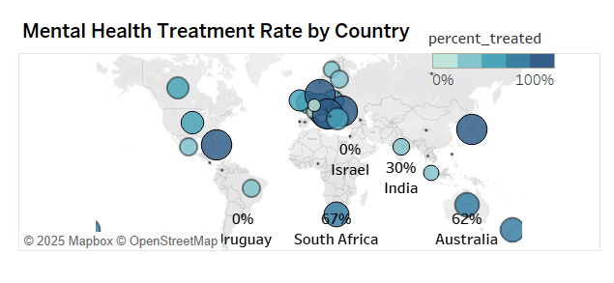
- Bubble Map: Mental Health Treatment Rate by Country
Purpose: In order to avoid data misinterpretation, this visualisation attempts to identify regional trends in the rates of mental health treatment while offering important background information regarding the sample size from each nation.
Design Justification: As a more intellectually honest option to a typical choropleth (filled) map, a bubble map was chosen. When data density varies significantly, a choropleth map may be deceptive because a large country with only one or two respondents may be prominently shaded. By encoding two distinct variables, the size of the bubble denoting the number of survey respondents and the color denoting the treatment rate, the bubble map deftly avoids this. The large bubble over the US is obviously more representative than the small bubble over Japan, and this dual encoding instantly alerts the viewer to the accuracy of the data for each nation.
Alternatives Considered: Since it would eliminate all geographic context, a straightforward bar chart displaying rates by nation was rejected. Because it strikes a balance between spatial representation and a visual, unambiguous indicator of data quality, the bubble map was the better option.

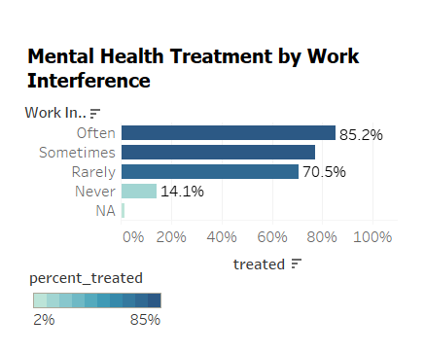
- Horizontal Bar Chart: Mental Health Treatment by Work Interference
Purpose: The purpose of this chart was to demonstrate the strong relationship between the likelihood of seeking treatment and the perceived frequency of work interference.
Design Justification: For better readability, a horizontal bar chart was selected rather than a vertical one. Without being truncated or rotated at an awkward angle, the long text-based category labels ("Often," "Sometimes," "Rarely," and "Never") can be presented neatly. The strong positive correlation is immediately visible due to the bars' logical descending order, which produces a seamless visual flow. While percentage labels offer accuracy, using a single color for the bars draws the viewer's attention to their length, which is the main data dimension.
Alternatives Considered: Pie charts were quickly disregarded because they are notoriously bad at comparing multiple categories. Since the main objective was to compare the treatment rates between the various interference levels, a straightforward bar chart that only shows the "Yes" percentage is more impactful, less complicated, and more direct than a stacked bar chart that shows the yes/no treatment breakdown for each interference category.
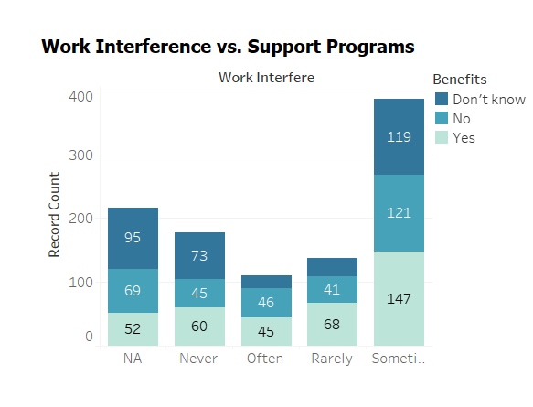
- Stacked Bar Chart: Work Interference vs. Support Programs
Purpose: This graph examines employees' perceptions of organizational support programs' accessibility, broken down by the extent to which their mental health affects their ability to perform their jobs.
Design Justification: The part-to-whole composition of benefit awareness ("Yes," "No," and "Don't Know") within each work interference level is displayed on your dashboard using a stacked bar chart. Because it enables the viewer to evaluate the internal division of each category, this design works well. For instance, it is easy to see that the "Don't Know" and "No" segments account for a significant amount of the total for the "Sometimes" group. A comparison of the absolute number of individuals in each interference category is also possible due to the overall height of each bar.
Alternatives Considered: An effective substitute was a grouped bar chart. Comparing a single benefit category across all interference levels (for example, the absolute number of "Don't Know" responses) would be simpler. The key finding regarding the high degree of uncertainty and lack of awareness among employees is directly supported by the stacked design, which was selected because it better illustrates the proportional breakdown within each bar.
  - Color and Labelling Choices:
Both aesthetic appeal and clarity were taken into consideration when choosing the colors. The consistent shades for Male, Female, and Other categories make it simple to distinguish between genders. The symbol map represents percentage values using a blue gradient. Labels are used sparingly but efficiently to avoid clutter. Every chart has a descriptive title to help users understand it. Tooltip information, which provides thorough breakdowns without overcrowding the visuals, was added to the live Tableau version to aid user exploration. Viewers can follow a logical progression thanks to the layout, which starts with gender-based analysis and moves on to country-level trends, interference impacts, and organizational response.
  - Interactive elements:
The gender and country filters in the original Tableau dashboard allow users to slice data dynamically, even though they are not visible in the static image. Additionally, parameters for alternating between absolute counts and percentages were considered. The dashboard becomes more insightful and user engagement is improved by these interactive elements. A user might, for instance, filter by "Female" to investigate treatment patterns in various nations or see how work interference differs for people who identify as "Other" gender. Instead of being a static report, the dashboard's flexibility turns it into a potent exploratory tool.
  - Dashboard Layout and Professionalism:
Interactivity: The dashboard is a dynamic analytical tool rather than just a still image. The bubble map's "Use as Filter" action is its main interactive element. This facilitates focused exploration by enabling the user to click on any country and instantly filter the remaining three charts. This feature enables the user to go beyond general statistics and pose more in-depth queries, such as whether the gender gap persists in the UK or how respondents in Canada differ in their awareness of support.
2.6. Professionalism and Layout: The dashboard maintains a polished appearance by using standardized fonts, distinct titles, and ideal spacing to prevent clutter. Beginning with demographics, the Z-pattern layout carefully directs the viewer's gaze across the visualisations before descending to geographic information, behavioral correlations, and organizational factors. This produces a coherent storyline that makes for an easy and perceptive user experience.
3. Key Findings and Analysis
Finding 1: Significant Gender Disparity in Treatment Seeking
The gender gap on the dashboard is immediately apparent. Males predominate among respondents who have not sought treatment, according to the "Treated Employees by Gender" chart. The group that has sought treatment, on the other hand, is more evenly distributed. This suggests that although there are more men in the tech sector (at least according to this survey), they are comparatively less likely to seek mental health treatment. This result is consistent with larger cultural patterns that show that stigma and the fear of being seen as weak can be major obstacles to men seeking medical attention.
Finding 2: Geographic Variation is Heavily Influenced by Data Skew
Although the bubble map shows stark variations in treatment rates around the world, its primary purpose is to set the scene for data reliability. Countries with extreme rates (such as 100% or 0%) have very small sample sizes, which makes those percentages statistically fragile, as the bubble sizes make evident. The dataset's strong concentration in the US, UK, and Canada is the true revelation. As a result, the map serves as a responsible visualisation, showing the areas of the data that are most reliable rather than allowing the user to make rash decisions.
Finding 3: Work Interference is a Powerful Motivator for Treatment
There is a clear, strong positive correlation: people are more likely to seek treatment if their mental health condition interferes with their ability to do their job. Even for those who experience interference "Rarely," the rate is still high at 70.5%, with an overwhelming 85.2% of those who report it "Often" seeking assistance. This implies that one of the main motivators for action is the noticeable effect on job performance. This is a crucial realization for employers since self-reported work interference can be a vital sign of employees who might require proactive assistance.
Finding 4: A Widespread Breakdown in Communicating Support
A significant organizational failure is revealed by the chart that looks at support programs. When questioned about employer-provided benefits, a significant portion of respondents gave "Don't Know" or "No" answers across all levels of work interference. The largest group, those who "Sometimes" encounter interference, is most affected by this. This suggests a serious breakdown in communication. If workers are not aware of the benefits, they are essentially "benefits-in-name-only." One of the biggest obstacles to enhancing mental wellness in the workplace is the institutional failure to offer and effectively communicate easily accessible support networks.
3.1. Integrated and Unexpected Insights
Integrated Insight: When viewed as a whole, the dashboard clearly illustrates how employees are often let down by the organizational support system, even though the personal stress of work-related disruptions encourages them to seek assistance. Cultural factors, like the stigma that may keep men from seeking care, exacerbate this communication and access breakdown. Employees are essentially motivated to seek treatment by personal struggles, but institutional and societal structures frequently fall short in offering sufficient support.
Unexpected Insight: It is surprising to learn that people who "Rarely" encounter work-related disruptions have a high treatment rate (70.5%). This group's rate might be expected to be more in line with the "Never" category. This implies that in a high-performance tech culture, even small or infrequent disruptions serve as a powerful motivator for help-seeking. It shows that a larger population is actively involved in managing their mental health and challenges the notion that only those experiencing a severe crisis seek help.

4. Conclusion
The dashboard for this project skillfully combines behavioral, demographic, and geographic data to provide important insights into the mental health situation in the tech sector. Clarity, analytical depth, and intellectual honesty served as the guiding principles for the visualisation design decisions, producing an intuitive and educational tool.
The main conclusions show that although work-related disruptions are a strong motivator for seeking treatment, there are serious shortcomings in the knowledge and availability of employer-sponsored support services. A time-series analysis of changing trends could be performed in the future by incorporating more recent, post-pandemic data. Furthermore, incorporating natural language processing (NLP) into the survey's open-ended comments section may reveal detailed qualitative accounts, giving the quantitative results a more profound and intimate aspect.

